Notes Application

Project link in Github :

<https://github.com/Abishek-KJ/Notes_Application.git>

By :

K.J.Abishek (238124) A.Akash (238315)

E.P.Prabhu (238102)

Project Name: Notes Application

\* Description:

* In an increasingly digital world, the demand for efficient and user-friendly note-taking applications has never been higher. Our Notes Application project aims to meet this need by offering a versatile and intuitive platform for users to capture, organize, and manage their thoughts, ideas, and tasks. Whether for personal use, educational purposes, or professional tasks, the application will provide a seamless experience across various devices. With features like rich text formatting, users can quickly find and organize their notes. The application's design prioritizes simplicity and accessibility, ensuring that even the most non-technical users can navigate it with ease.
* The Notes Application is built with scalability and security in mind, utilizing a robust backend to handle large volumes of data while keeping user information secure. Users will have the ability to create and categorize notes in multiple notebooks, share notes with others, and collaborate in real-time.
* The application offers a variety of features to enhance user productivity and organization. Users can create notes with rich text formatting and organize them into notebooks.

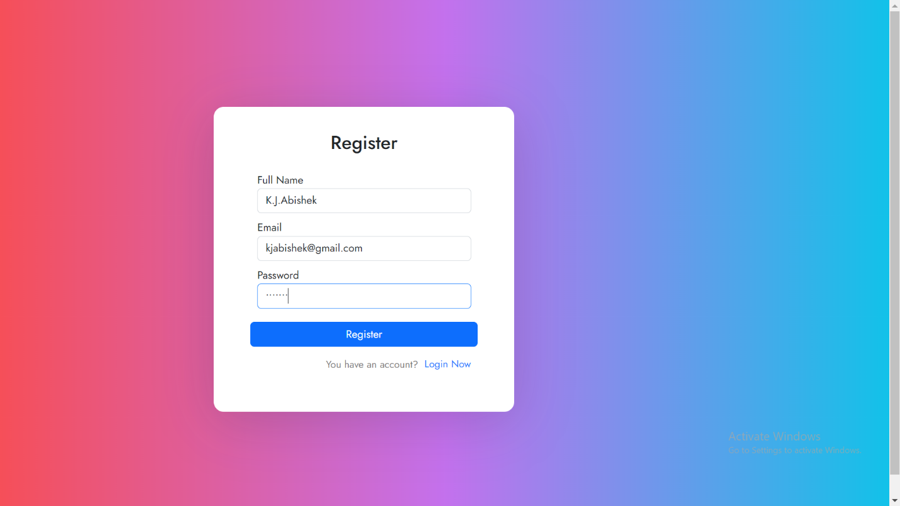Registration Page:

Login Page:

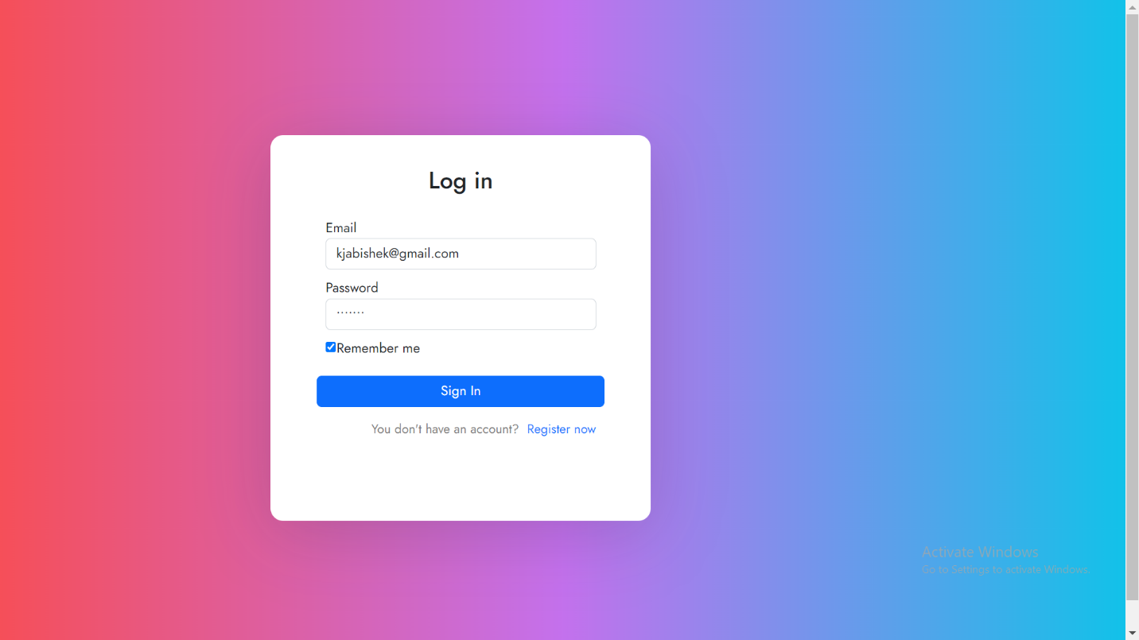

Home Page:

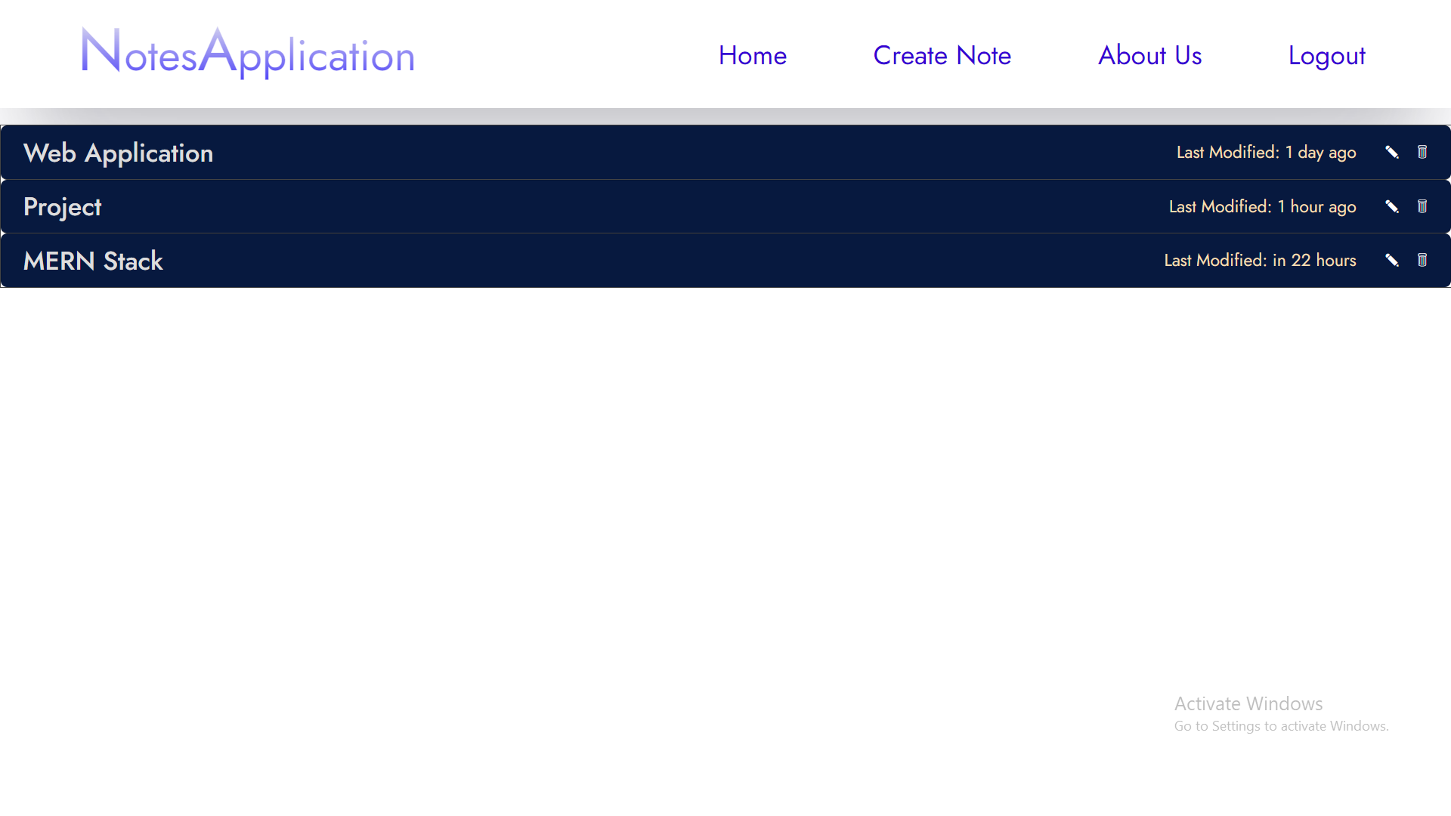Created notes will be listed here :

Create Notes:

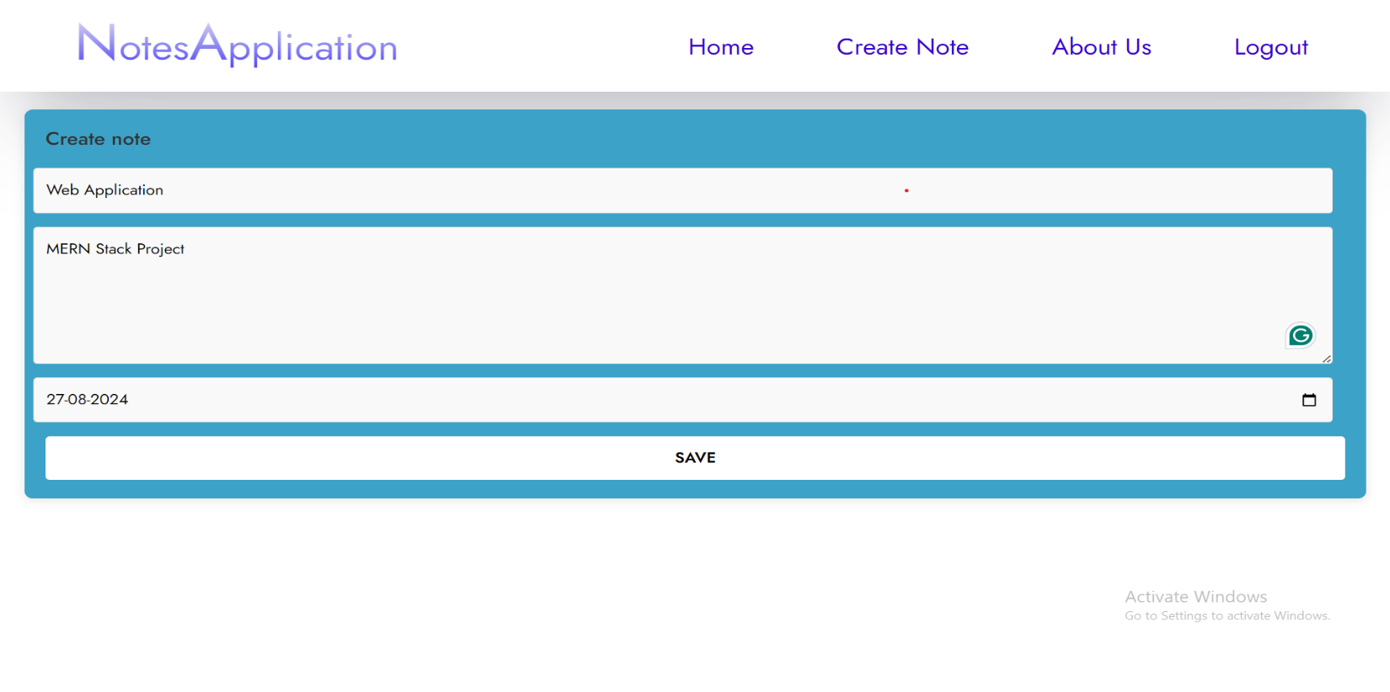You can create your notes here :

Edit Notes :

We can edit notes here :

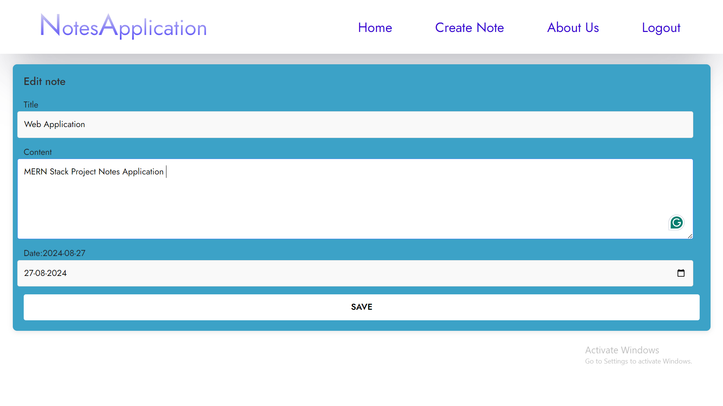

About us Page :

